

Placement Empowerment Program

Cloud Computing and DevOps Centre

**Set Up IAM ROLES**

Name:Manashaa U Department: CSE

Introduction:

In this Proof of Concept (POC), I have assigned roles(IAM) in my VM

Step-by-Step Overview Step

1)create a VM and click on “management

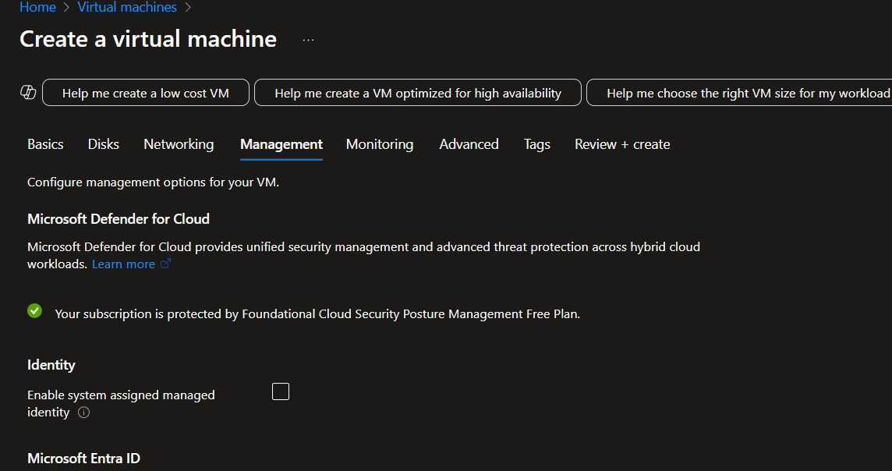

2. enable system assign

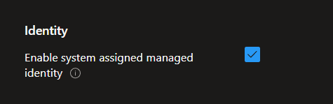

3.Create virtual machine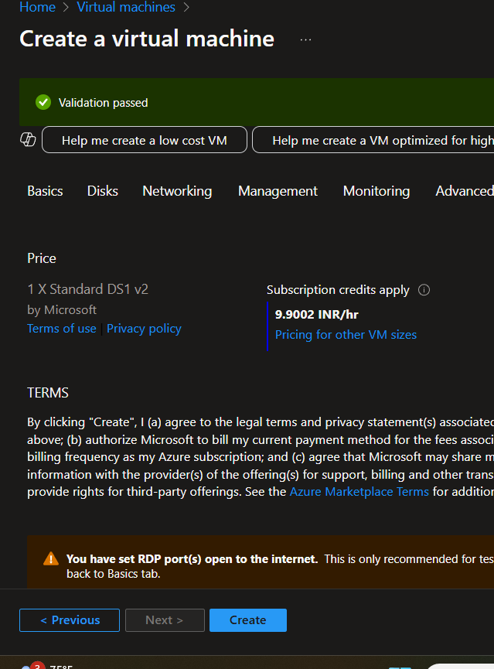

4.go to “access control” 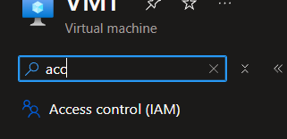

5.click on “add” to create and assign role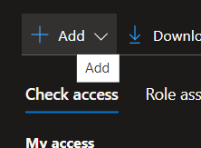

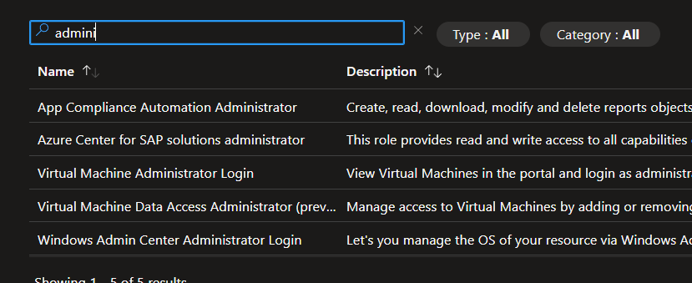

Outcome:

This will effectively grant controlled access to Azure resources without the need to share long-term credentials like passwords; essentially, it enables secure delegation of access to Azure services and resources to various entities within your account.